**Figure S1. Early positive response**

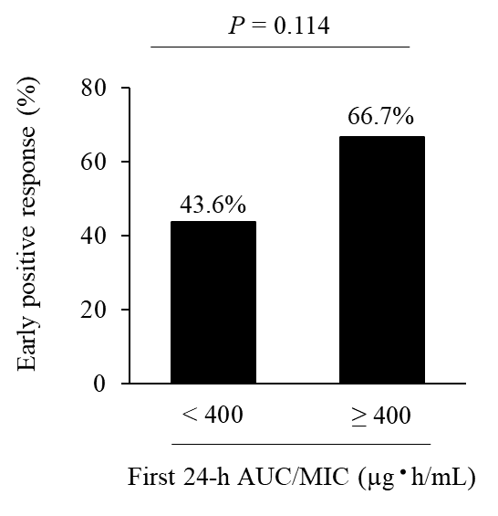

The Figure shows the early positive response rate in the < 400 group and the ≥ 400 group. Values are presented as number (%).

AUC/MIC, area under the concentration-time curve/minimum inhibitory concentration.