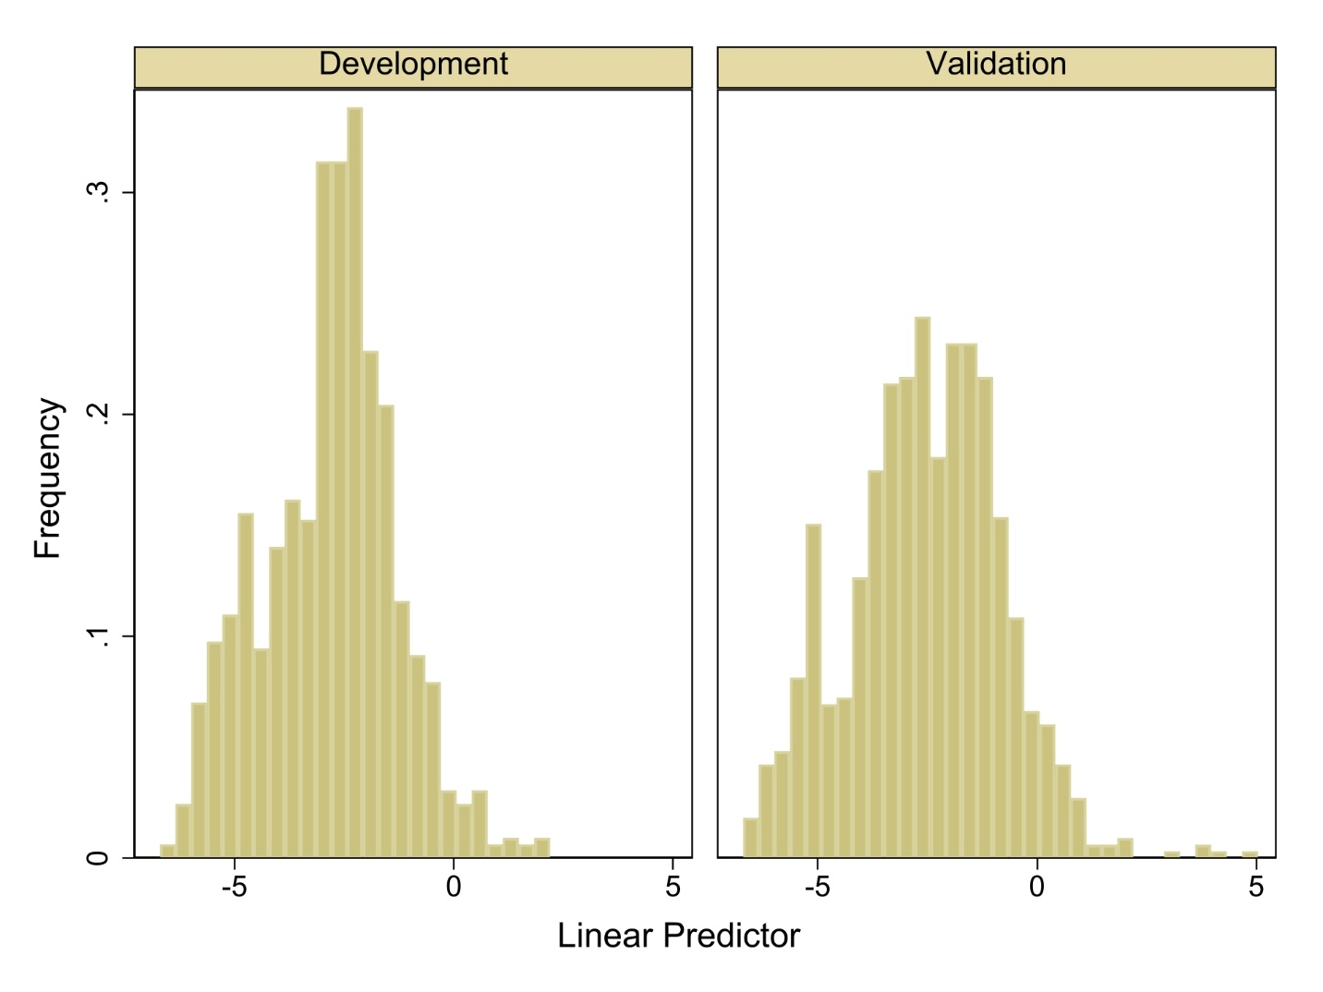
Suppl 2. Histogram of linear predictor (LP) derived from development (left column) and validation dataset (right column). Comparison of the mean linear predictors (LP) and its standard deviation (SD) between the development and validation cohorts. The mean LP was −2.84 in the development cohort and −2.54 in the validation cohort (p < 0.001), while the SD was 1.54 and 1.75, respectively (p < 0.001).

