Suppl 2. CD19 lymphocytes before each rituximab cycle
(A) Multiple sclerosis
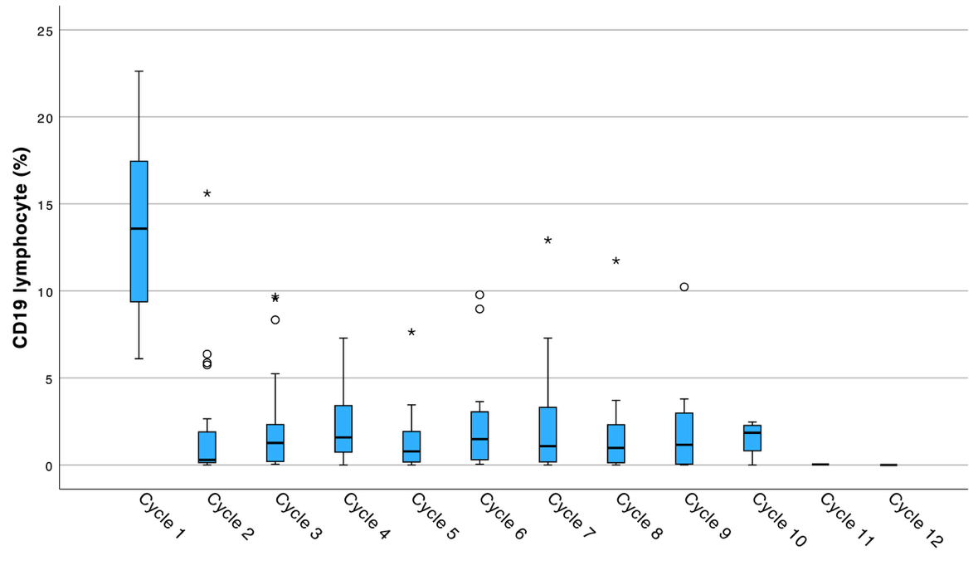
(B) AQP4-IgG-seropositive neuromyelitis optica spectrum disorder
