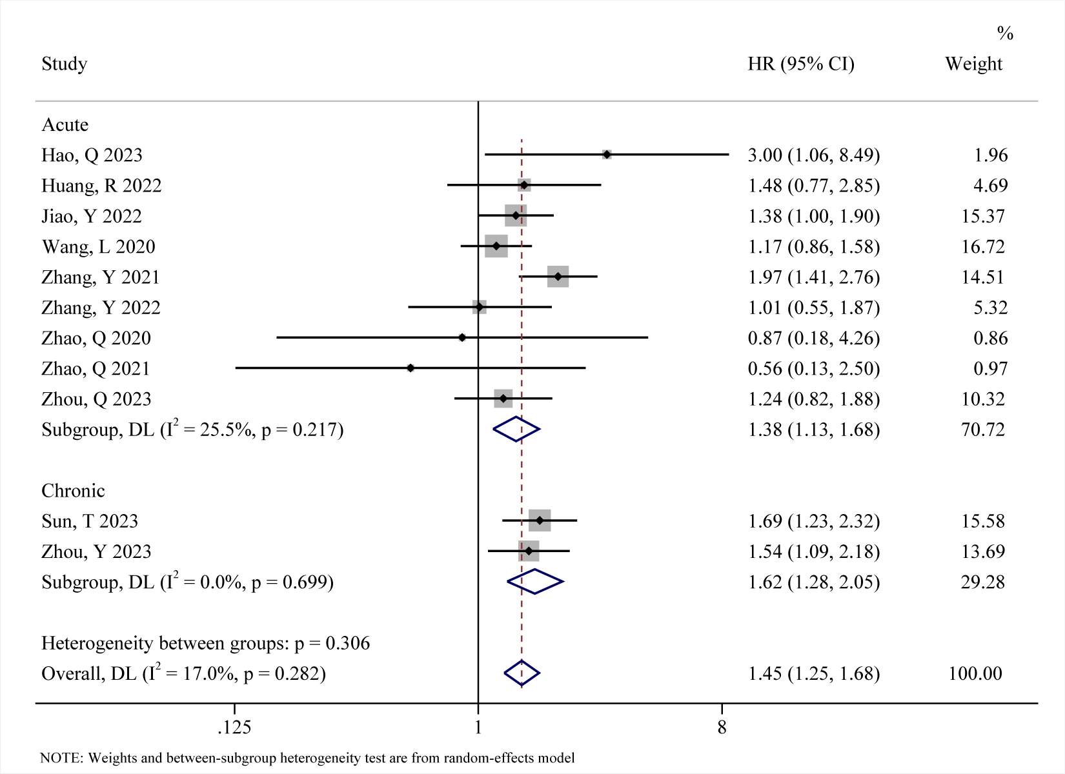

Suppl 4. All-cause subgroup.

