Suppl 4a. Risk of bias in the nine randomized trials assessed with the Cochrane RoB 2

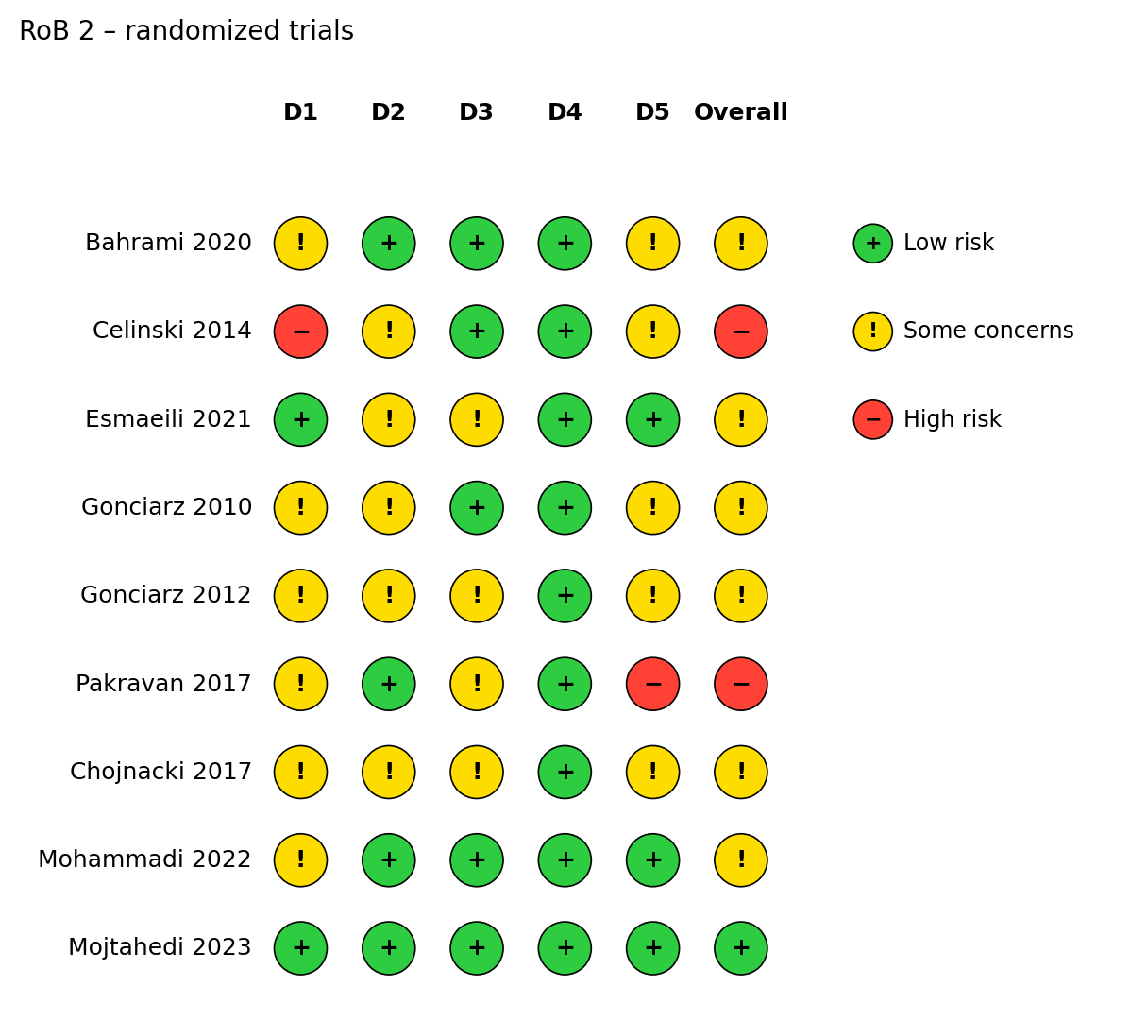

Suppl 4b. Risk of bias in the two non-randomized studies assessed with ROBINS-I

