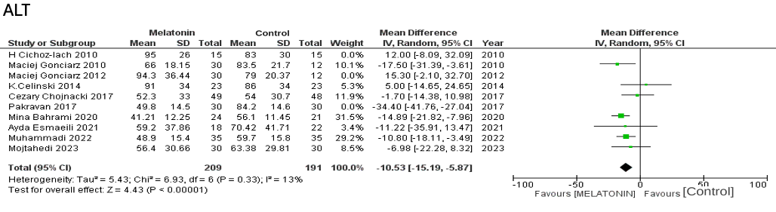

Suppl 10. Forest plot showing the post-sensitivity analysis of ALT

