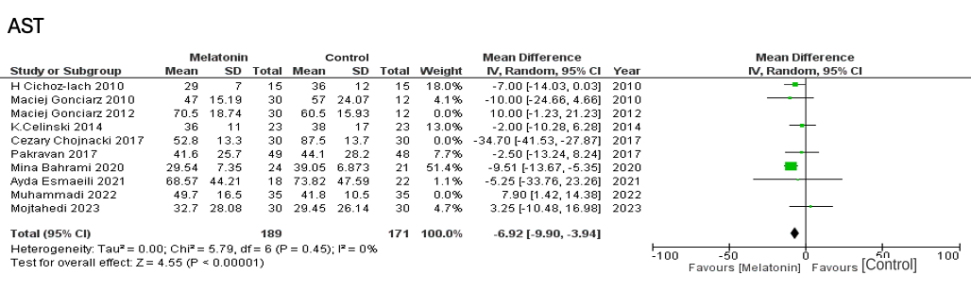

Suppl 11. Forest plot showing the post-sensitivity analysis of AST

