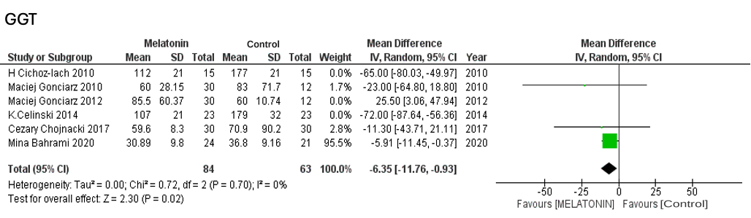
Suppl 12. Forest plot showing the post-sensitivity analysis of GGT

