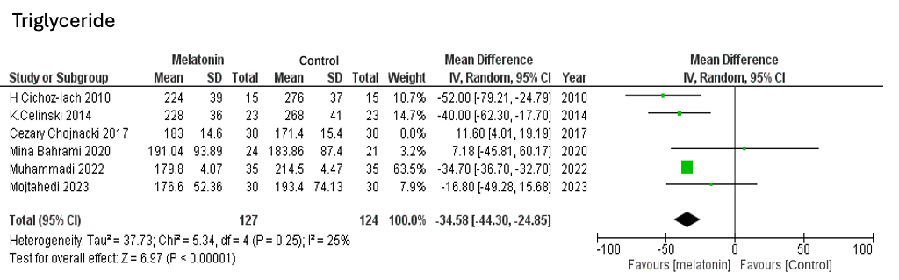

Suppl 13. Forest plot showing the post-sensitivity analysis of triglycerides

