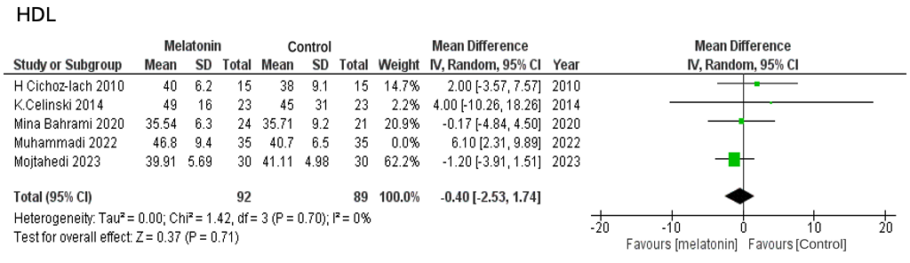

Suppl 14. Forest plot showing the post-sensitivity analysis of HDL

